Plugging into the Future: An Exploration of Electricity Consumption Patterns Using Tableau

TEAM ID: LTVIP2026TMIDS44168
NAME: G HEMA

Project Overview:
This project analyzes electricity consumption patterns using Tableau.
It explores how electricity usage changes based on:
Time of day
Seasons
Different sectors (Residential, Commercial, Industrial)
The goal is to provide insights that help improve energy management and promote sustainable electricity usage.
Objectives:
Analyze electricity usage at different times of the day.
Identify peak demand periods.
Study seasonal consumption variations.
Compare electricity usage across sectors.
Create interactive dashboards using Tableau.
Tools and Technologies:
Tableau Public / Tableau Desktop
CSV dataset
HTML
CSS

Project Structure:
Electricity-Consumption-Tableau/
├── Electricity_Consumption_Report.pdf
├── time_of_day.png
├── seasonal.png
├── sector.png
├── electricity_consumption.csv
├── index.html
└── style.css
Dashboard Screenshots:
- Time-of-Day Consumption
Shows electricity usage at different hours.
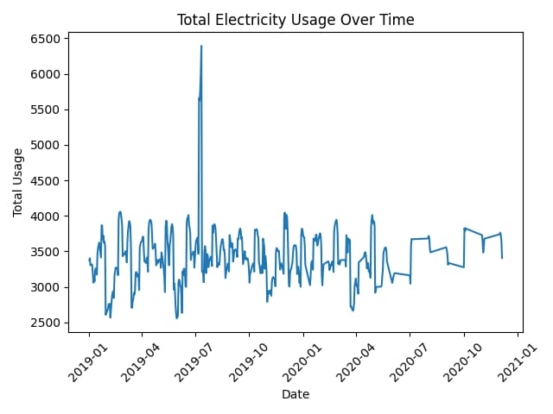
- Seasonal Consumption
Shows electricity demand across different seasons.
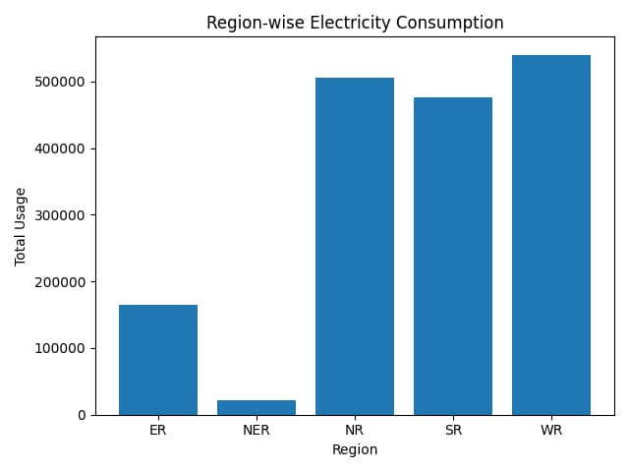
- Sector-wise Consumption
Shows electricity usage across residential, commercial, and industrial sectors.
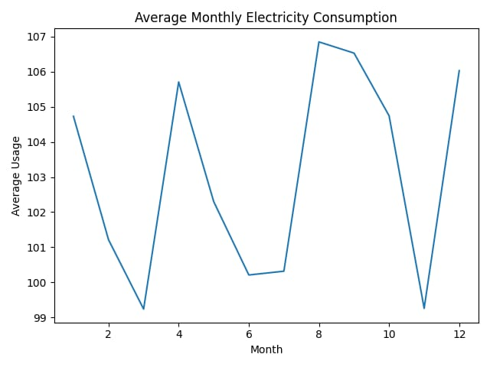
Key Insights:
Evening hours show peak residential electricity usage.
Summer season has the highest electricity demand.
Industrial sector consumes the most electricity overall.
Conclusion:
This project demonstrates how Tableau can be used to analyze electricity consumption patterns. The visual insights help in better energy planning, load management, and sustainable electricity usage.
GITHUB LINK:
https://github.com/Hema98765

